**Java - Introduction to Programming**

**Lecture 6**

**Patterns - Part 2**

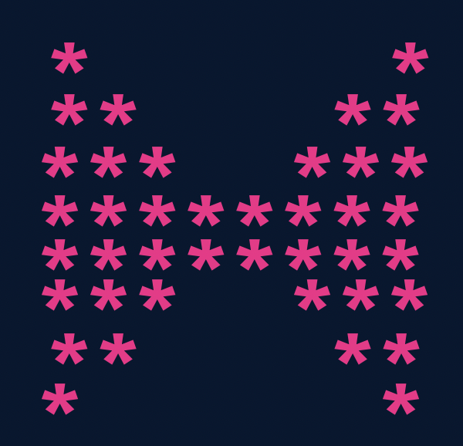

import java.util.*;

public class Solutions {

public static void main(String args[]) {

int n = 4;

//upper part

for(int i=1; i<=n; i++) {

for(int j=1; j<=i; j++) {

System.out.print("*");

}

int spaces = 2 * (n-i);

for(int j=1; j<=spaces; j++) {

System.out.print(" ");

}

for(int j=1; j<=i; j++) {

System.out.print("*");

}

System.out.println();

}

//lower part

for(int i=n; i>=1; i--) {

for(int j=1; j<=i; j++) {

System.out.print("*");

}

int spaces = 2 * (n-i);

for(int j=1; j<=spaces; j++) {

System.out.print(" ");

}

for(int j=1; j<=i; j++) {

System.out.print("*");

}

System.out.println();

}

}

}

1. 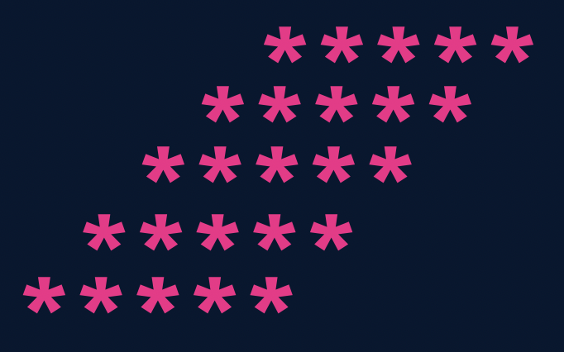

import java.util.*;

public class Solutions {

public static void main(String args[]) {

int n = 5;

for(int i=1; i<=n; i++) {

//spaces

for(int j=1; j<=n-i; j++) {

System.out.print(" ");

}

//stars

for(int j=1; j<=n; j++) {

System.out.print("*");

}

System.out.println();

}

}

}

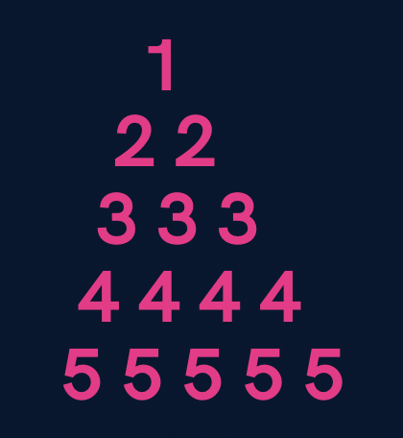

import java.util.*;

public class Solutions {

public static void main(String args[]) {

int n = 5;

for(int i=1; i<=n; i++) {

//spaces

for(int j=1; j<=n-i; j++) {

System.out.print(" ");

}

//numbers

for(int j=1; j<=i; j++) {

System.out.print(i+" ");

}

System.out.println();

}

}

}

1. 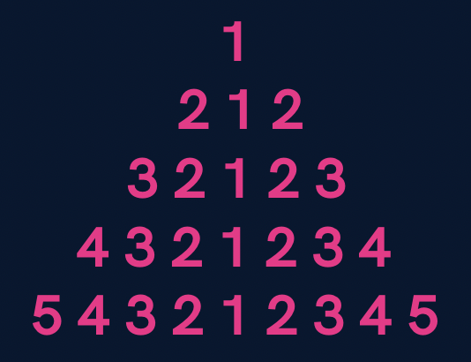

import java.util.*;

public class Solutions {

public static void main(String args[]) {

int n = 5;

for(int i=1; i<=n; i++) {

//spaces

for(int j=1; j<=n-i; j++) {

System.out.print(" ");

}

//first part

for(int j=i; j>=1; j--) {

System.out.print(j);

}

//second part

for(int j=2; j<=i; j++) {

System.out.print(j);

}

System.out.println();

}

}

}

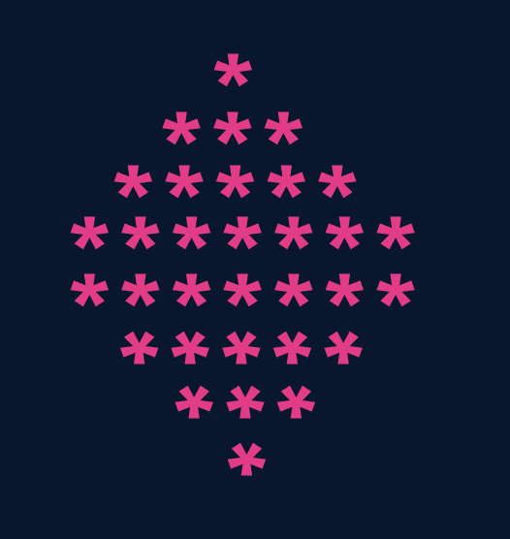

import java.util.*;

public class Solutions {

public static void main(String args[]) {

int n = 5;

//upper part

for(int i=1; i<=n; i++) {

//spaces

for(int j=1; j<=n-i; j++) {

System.out.print(" ");

}

for(int j=1; j<=2*i-1; j++) {

System.out.print("*");

}

System.out.println();

}

//lower part

for(int i=n; i>=1; i--) {

//spaces

for(int j=1; j<=n-i; j++) {

System.out.print(" ");

}

for(int j=1; j<=2*i-1; j++) {

System.out.print("*");

}

System.out.println();

}

}

}

**Homework Problems**

1. **Print a hollow Butterfly.**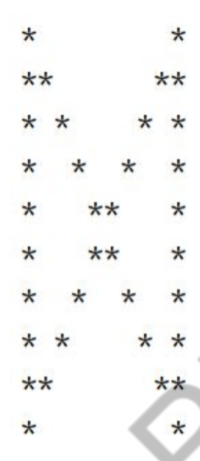

1. **Print a hollow Rhombus.**

*****

* *

* *

* *

*****

1. **Print Pascal’s Triangle. (Doubt)**

1

1 1

1 2 1

1 3 3 1

1 4 6 4 1

1. **Print half Pyramid. (done)**

1

1 2

1 2 3

1 2 3 4

1 2 3 4 5

1. **Print Inverted Half Pyramid.**

1 1 1 1 1

2222

333

44

5